**Τα πρoϊόντα της Κύπρου**

1. Ψάξε στο κρυπτόλεξο και βρες 8 προϊόντα της Κύπρου.

|  |  |  |  |  |  |  |  |  |  |
| --- | --- | --- | --- | --- | --- | --- | --- | --- | --- |
| Χ | Ε | Λ | Ι | Ε | Σ | Ρ | Κ | Ι | Χ |
| Δ | Π | Ο | Ε | Δ | Υ | Φ | Ρ | Κ | Α |
| Μ | Α | Κ | Λ | Δ | Κ | Φ | Α | Ω | Λ |
| Τ | Τ | Α | Ψ | Ω | Α | Γ | Σ | Β | Λ |
| Κ | Α | Ρ | Π | Ο | Υ | Ζ | Ι | Α | Ο |
| Σ | Τ | Α | Φ | Υ | Λ | Ι | Α | Δ | Υ |
| Ζ | Ε | Ε | Ν | Μ | Σ | Π | Θ | Υ | Μ |
| Π | Σ | Α | Ε | Τ | Β | Ψ | Μ | Ξ | Ι |
| Π | Ο | Ρ | Τ | Ο | Κ | Α | Λ | Ι | Α |

2. Γράψε τις λέξεις που βρήκες κάτω από τη σωστή εικόνα (με μικρά γράμματα):

[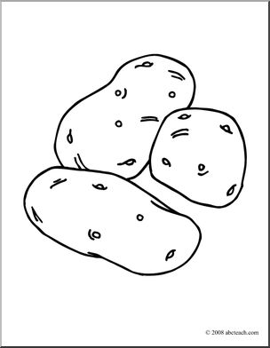](http://www.google.co.uk/url?sa=i&rct=j&q=&esrc=s&source=images&cd=&cad=rja&uact=8&ved=0ahUKEwiS24-P_qDZAhWpJcAKHdV4ATkQjRwIBw&url=http://moziru.com/explore/B%26w%20clipart%20potato/&psig=AOvVaw0XKqdci033l4VRy5goZeuI&ust=1518545677087050)[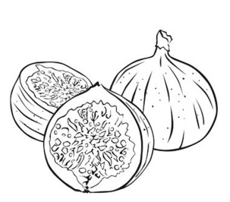](http://www.google.co.uk/url?sa=i&rct=j&q=&esrc=s&source=images&cd=&cad=rja&uact=8&ved=0ahUKEwj3w-ij_KDZAhUHCcAKHXotBOUQjRwIBw&url=http://desenhosparacolorireimprimir.com/desenhos-de-frutas-para-colorir/&psig=AOvVaw063u71bZBT0Qoxryr6Z4wS&ust=1518545297086380)

[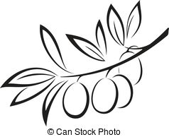](https://www.google.co.uk/url?sa=i&rct=j&q=&esrc=s&source=images&cd=&cad=rja&uact=8&ved=0ahUKEwjY3u-2_aDZAhWELcAKHcv3BOMQjRwIBw&url=https://www.canstockphoto.com/retro-olive-harvest-label-black-and-43853127.html&psig=AOvVaw03vP7wQGg-yjXpxH1DADLO&ust=1518545452448644)[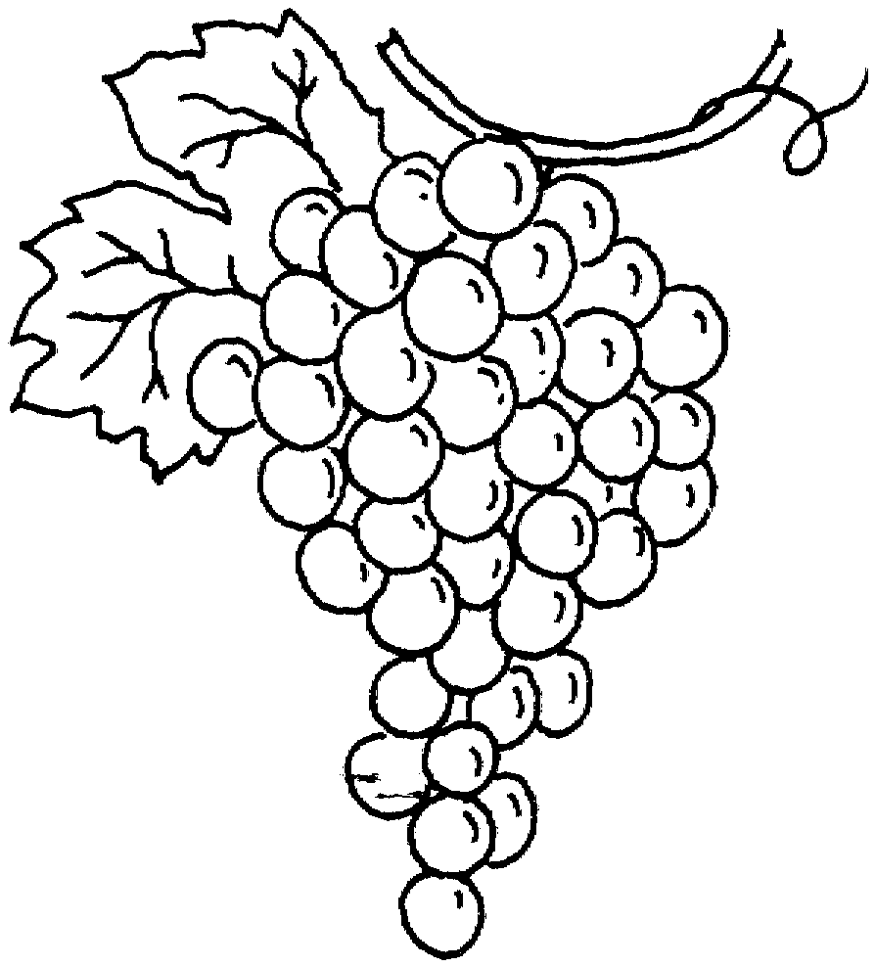](http://www.google.co.uk/url?sa=i&rct=j&q=&esrc=s&source=images&cd=&ved=0ahUKEwj-89jN_KDZAhWCIMAKHc5fBHQQjRwIBw&url=http://moziru.com/explore/Monochrome%20clipart%20grape/&psig=AOvVaw1Wfhtk7EBrulBhxQ4k0r2u&ust=1518545397007705)

_____________ ______________ ______________ ____________

[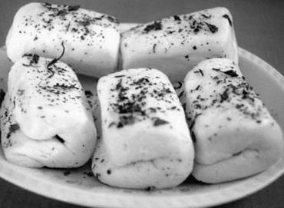](http://www.google.co.uk/url?sa=i&rct=j&q=&esrc=s&source=images&cd=&ved=0ahUKEwjO_KyigaHZAhXmKcAKHdpEDhwQjRwIBw&url=http://terra48.ru/syr-hallumi-v-domashnih-usloviyah/&psig=AOvVaw1MS_MMf8C0ZuMMIUHHKqnc&ust=1518546652883251)[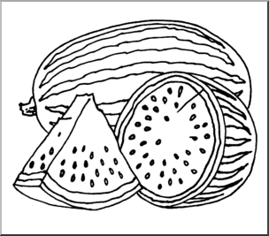](http://www.google.co.uk/url?sa=i&rct=j&q=&esrc=s&source=images&cd=&cad=rja&uact=8&ved=0ahUKEwjpjLC8_qDZAhVUPsAKHa2OCokQjRwIBw&url=http://moziru.com/explore/Watermelon%20clipart%20circle/&psig=AOvVaw3gh_YGU-0PWYhElgflr_Fg&ust=1518545896672727)[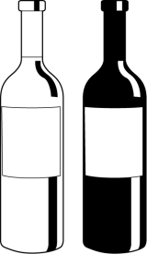](http://www.google.co.uk/url?sa=i&rct=j&q=&esrc=s&source=images&cd=&cad=rja&uact=8&ved=0ahUKEwig3dey_6DZAhVoLsAKHV12ADEQjRwIBw&url=http://cliparting.com/free-wine-clipart-31436/&psig=AOvVaw1e5vNcevwLp0ah8CPxW_kc&ust=1518546129158132)[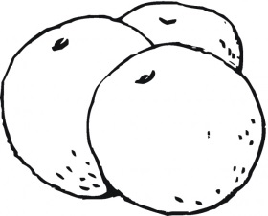](http://www.google.co.uk/url?sa=i&rct=j&q=&esrc=s&source=images&cd=&cad=rja&uact=8&ved=0ahUKEwjooNz3_qDZAhVCPsAKHTwOB3UQjRwIBw&url=http://moziru.com/explore/Orange%20clipart%20coloring%20page/&psig=AOvVaw000zMUpeWzQJHs6Jh5tmyO&ust=1518545980211970)

[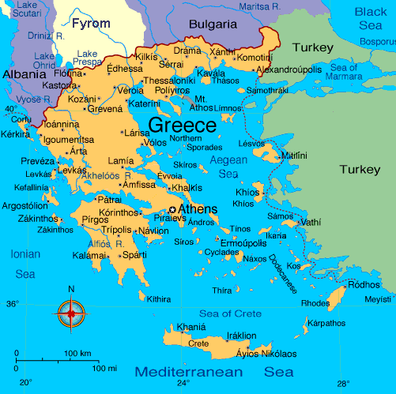](http://www.google.co.uk/url?sa=i&rct=j&q=&esrc=s&source=images&cd=&cad=rja&uact=8&ved=0ahUKEwiYwMuzocTYAhUEC8AKHXu5A2cQjRwIBw&url=http://livenaturallymagazine.com/recipes/grilled-halloumi-cheese/&psig=AOvVaw0wMVDQqc0O6AXT7FY-xHNl&ust=1515359722375436)

_____________ _______________ ________________ _______________